IT SUPPORT SERVICES TENDER

Active Gloucestershire Ltd is a company limited by guarantee in England and Wales with charitable status
Registered Office: City Works, Alfred Street, Gloucester, United Kingdom, GL1 4DF
Company number: 7344552 Charity number: 1138546

Date issued: 30 September 2021

Disclaimer: This is an Invitation to Tender (ITT) only. Active Gloucestershire is not obliged to proceed further.
Table of Contents
Introduction 3
Who we are 3
Inspire, connect and enable 4
Objectives and requirements of tender 5
Maintaining systems and providing support 5
Moving to the cloud 6
Looking to the future 6
System Overview 6
Current setup 7
Server 7
Devices 7
Microsoft email accounts 7
Software Packages 8
Printers 8
Networking 8
Remote access 8
Patch management 8
IT Support Service provision 2021 9
Tender Deadlines 9
Enquiries 9
Cost of Submission 10
Evaluation Criteria 10
Reference Checks 10
Transition Process 10
Shortlisting 10

Introduction

Who we are
We believe that physical activity can have a transformative impact on the lives of people and their communities. It is the single biggest thing that can be done to improve a person’s health. We are part of a national network of Active Partnerships operating across England. At our essence we are about driving positive change.

As a trusted organisation, Active Gloucestershire coordinates we can move. Inspiring people to unite behind a common vision to increase physical activity. Connecting individuals and organisations to build strong collaborative partnerships. Enabling the growth and impact of we can move, through providing a range of resources, training, and support.

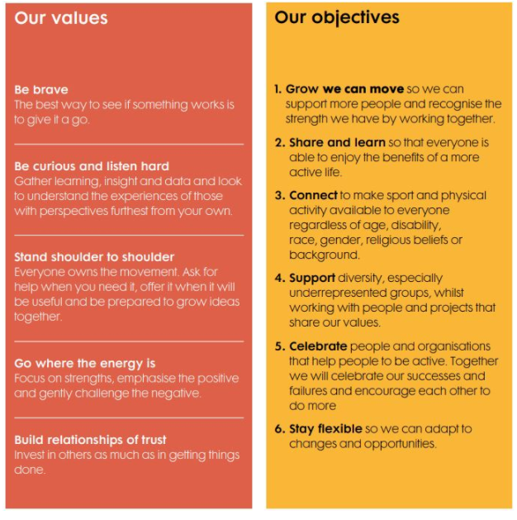
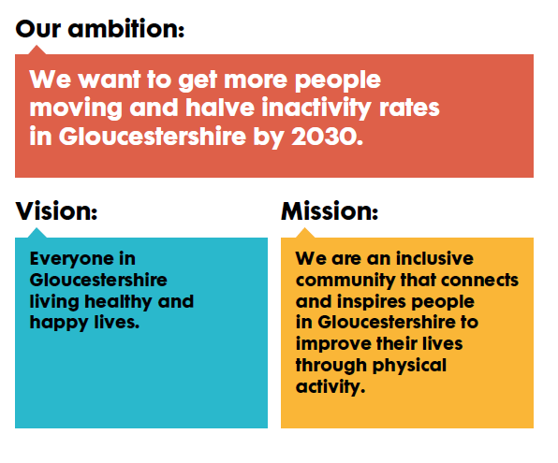

Inspire, connect and enable
Active Gloucestershire works to the core principals of inspire, connect and enable:
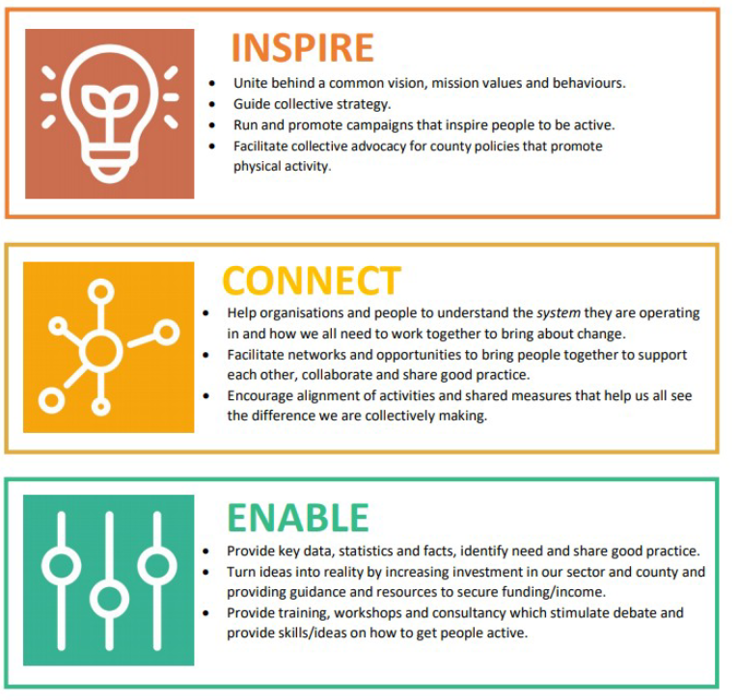

Objectives and requirements of tender
Active Gloucestershire (AG) currently outsources its IT requirements to Rock IT on an IT managed service basis and IT is overseen internally by the Head of Insight and Intelligence. We are re-tendering for this service to ensure that our IT managed service remains fit for purpose in supporting our organisational needs. To provide good value and support our mission to engage with and grow our movement. We are looking to enter into a contract for a minimum of 2 years.
We have been reviewing our IT over the past 18 months and putting in place several improvements to our processes and security. Our current focus is to
- Move Active Gloucestershire away from physical servers and use cloud storage and Azure AD for user management
- Get Active Gloucestershire into the position to successfully apply for Cyber Essentials, preferably within this financial year
- Look at how we can use IT and our data to grow the we can move movement and support organisations across Gloucestershire.
- As with most businesses the pandemic has caused us to reflect on the appropriateness of our office space. This is under review and during this contract period there may be the requirement to relocate our main office location
Active Gloucestershire expects the successful tender applicant to assume and retain responsibility for the following areas:

Maintaining systems and providing support
- Ensuring AG's systems remain operational at all times, resolving any problems that arise quickly
- Providing unlimited remote and onsite support and responding to ad-hoc support requests, whilst also proactively and regularly assessing the organisation’s need and adapting its support to meet this
- Identifying any outdated equipment and advising when updates to our hardware or software are required.
- Ensuring that staff can work remotely with easy access to files.
- Responding to Active Gloucestershire’s changing needs quickly and efficiently, for example in the event of expanding our staff numbers or changing office location
- Monitoring the network to help minimise downtime
- Ensuring AG's data is secure and backed up

Moving to the cloud
- At the commencement of the agreement to move AG from the physical server to the cloud
- Backup data held in shared drives on the server
- Upgrade Microsoft 365 Business Standard licences to Microsoft 365 Business Premium, utilising the options for not-for-profit organisations
- Joining all assets to Microsoft Azure AD
- Migrate profiles to Microsoft Azure AD
- Set up cloud-based patch management solution
- Reconfigure central printer so installed locally and scan to email rather than scan to network drive
- Disposal of old hardware

Looking to the future
- Providing AG with proactive support and guidance on developing and implementing our IT strategy and policies (including cyber security)
- Support AG application for Cyber Essentials accreditation
- Informing Active Gloucestershire of new legislation and new technology that may support and enhance the way we work and how or whether we implement these.
- Outlining options on the optimum system and use of software for AG and implementing any chosen changes

System Overview
Active Gloucestershire operates from one main office in Gloucester (City Works, Alfred Street, Gloucester, GL1 4DF). This office is located in a community building with other businesses and commercial projects.
We currently have 16 members of staff and may be expanding with a further 2 or3 staff joining our team during 2021/22. These staff members predominantly work remotely since the start of the Covid-19 pandemic. Coming together either at City Works or alternative locations across Gloucestershire when working more collaboratively.
We currently work via a hybrid IT solution which incorporates both on-site and cloud-based elements. The contract would commence with decommissioning of our physical server and the work connected to this. To help understand this part of the project, our current setup is detailed below. This includes improvements or changes expected to take place prior to commencement of the contract.

Current setup

Server
Active Gloucestershire have an on-site server (Dell PowerEdge T130, running Windows Server 2016 Essentials) which is for our local domain controller, covering DHCP, DNS, group security policies & group anti-virus rules. This is backed up using the onsite DATTO Alto device throughout the day, replicated to the Datto Cloud. The server was purchased in August 2018 and the warranty expired in August 2021. Recent review has confirmed the server is reporting in good health.

Devices
We currently have one desktop, with the remaining members of staff using laptops. We will be transferring this final member of staff from PC to a laptop before the end of 2021. This desktop is therefore outside of the scope of this tender.
We have several laptops previously used as communal devices when we were predominantly on desktop devices. These are in the process of being decommissioned and are therefore outside of the scope of this tender.
Three laptops purchased at the start of the pandemic are currently running on Microsoft Windows 10 Home x64. We will be upgrading these to Windows 10 Pro x64 before the end of 2021.
We expect the support to cover a total of 22 devices to be covered by this support which include devices:
16 members of staff with an additional two members expected to be recruited by the end of March 2022.
In addition to this we have one external contractor who we have provided a laptop for and would be covered under this support.
Two iPads and one iPhone for communal use.

Microsoft email accounts
Emails are hosted on Microsoft 365, email scanning and virus filtering provided by Mimecast.
There are three domains utilised on Microsoft 365: activegloucestershire.org, activegloucestershire.org.uk and wecanmove.net. Management of these sites and updates are carried out by third party agencies and outside of the scope of this tender.
We currently have 30 email accounts/licences, including one for an administrator and one for the IT provider.

Software Packages
The core software packages, or online systems used by AG are listed below, there will be others on top of this.
- Microsoft Office (Word, Excel, PowerPoint, Outlook, Teams)
- Sage online 50
- Sage HR
- Smartsheet
- BreatheHR
- Folderit
- Zoom
- Less Annoying CRM
- Miro
- Prezi
- Horizon
- Sociuu
- Tableau
- Decisions
- Otter
We are currently reviewing our finance system and testing other solutions such as Xero

Printers
There are two networked printers used by AG, one A3 printer and one multifunctional printer

Networking
There are three network switches providing wired connection and two SSID WiFi networks. There may be a future requirement to expand on this if we change our office location.
- AG_Staff – used by staff
- AG-Host – used by hosted staff and Active Gloucestershire staff (signal mainly in main office only)

Remote access
We currently hold 15 licenses for VPN service Sonic Wall NetExtender

Patch management
Group policy updates are run daily to download and install updates through the server

IT Support Service provision 2021
We have requested IT support 85 times between January and August 2021. With workstation, user account and software being the most common issues.
Issue | Count
Workstation | 17
User Account | 15
Software | 14
(blank) | 14
Email | 6
Server | 6
Printer | 6
Network | 5
Backups - Local Backup Error/Failed | 1
Domain - DNS Change | 1
Grand Total | 85
The time spent on service desk support has on average been just under four and a half hours per month.
Please ensure your proposal separates out the service cost and monthly licence costs out. If your proposal is beyond two years to also set out an inflation clause.

Tender Deadlines
Our existing IT support contract expires on 25th February 2022. We would expect the new IT managing service provider (should we decide to change) to liaise with our existing service provider to ensure a seamless transition, ahead of the contract commencement date of 25th February 2022.
Date of issue: | 30th September 2021
Tender submission deadline: | 29th October 2021
Notification of shortlist: | 5th November 2021
Meet shortlisted managing service providers: | 22nd November 2021
Notification of award of contract subject to contract: | 26th November 2021
Contract start date: | 25th February 2022
All tenders are to be submitted electronically to Alan Inman-Ward, alaninman-ward@activegloucestershire.org, with the subject ‘Active Gloucestershire - IT Tender Submission’.

Enquiries
Questions regarding the procurement or any elements of this tender process are to be submitted via email to Alan Inman-Ward, alaninman-ward@activegloucestershire.org, with the subject ‘Active Gloucestershire - IT Tender Questions’. Questions will not be accepted by telephone.

Cost of Submission
All costs associated with the preparation of a proposal or contract in response to this tender will be borne solely by the respondent.

Evaluation Criteria
Active Gloucestershire will choose their preferred IT managing service provider based on the following criteria:
- The respondent’s ability to meet the requirements of the scope of work and the respondent’s ability to deliver the requirements when and where required
- The respondent’s financial offer including but not limited to prices, operating and maintenance costs, warranty, and value-added services. Please split out proposed costings between decommissioning server and the ongoing support.
- The respondent’s proven experience in delivering a similar scope of work
- The respondent's business and technical reputation and capabilities, as well the sustainability of the company, experience and where applicable, the experience of its personnel, financial stability, references of current and former customers
- The quality of submission of the respondent’s tender document
- The respondent’s social value objectives and alignment to the values and goals of Active Gloucestershire
- The respondent’s service capabilities, including technical support and customer service
- The respondent’s ability to be proactive in supporting Active Gloucestershire’s compliance with new legislation and specifically informing us of the steps we as an organisation can take to ensure this compliance
- The respondent’s ability to support Active Gloucestershire with the development of a strategy, policies and using IT and data to achieve our mission
- The respondent’s ability to respond to any potential organisational expansion

Reference Checks
Active Gloucestershire would like to be provided with two references from organisations with a similar size setup. We reserve the right to contact the respondent’s customer(s), to make appropriate checks. Please provide these references with your tender documents.

Transition Process
As part of your tender submission, please explain how you would manage the transition from the incumbent provider (should we decide to move) and manage the process of decommissioning our physical servers.

Shortlisting
Those managing service providers that are shortlisted should be available for a meeting on Monday 22nd November 2021, at Active Gloucestershire’s office, (time to be confirmed). The managing service provider should be prepared to present their tender proposal and be ready to answer questions from a small panel.

